Command to download the images from local registery is

Lu1 – vid s next

Sigle steps build on controller

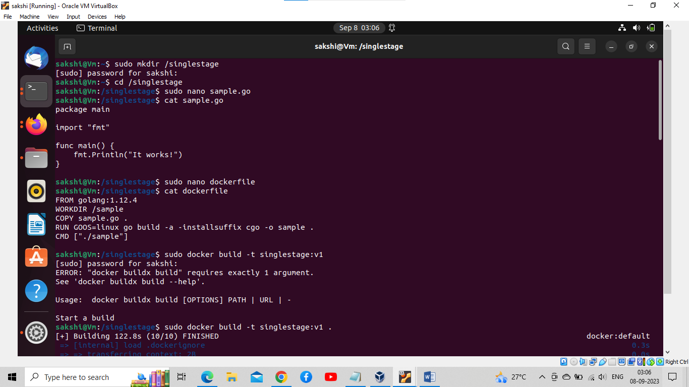

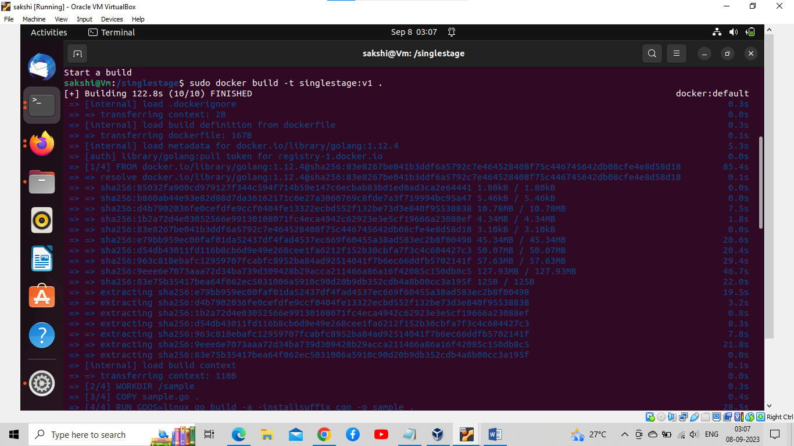

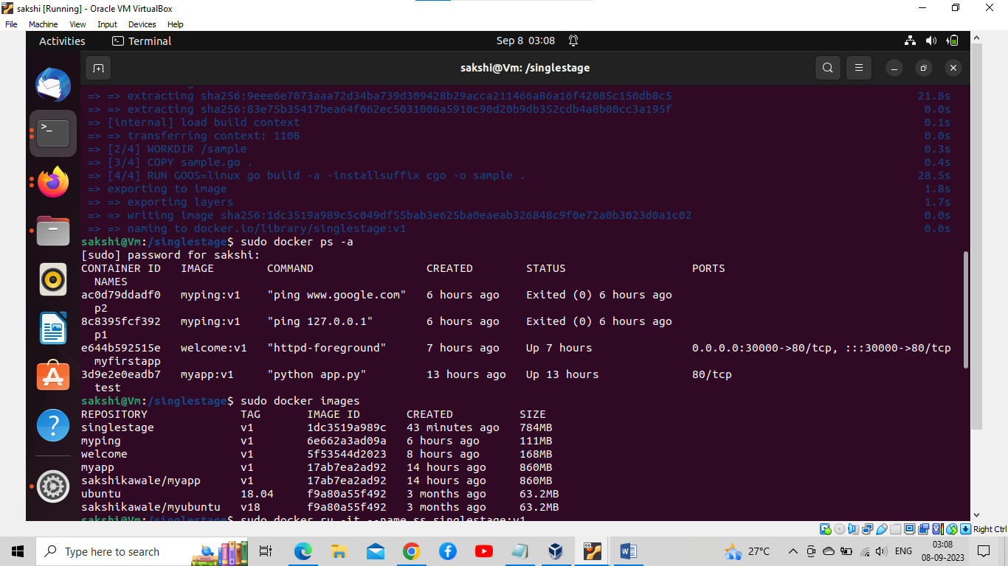

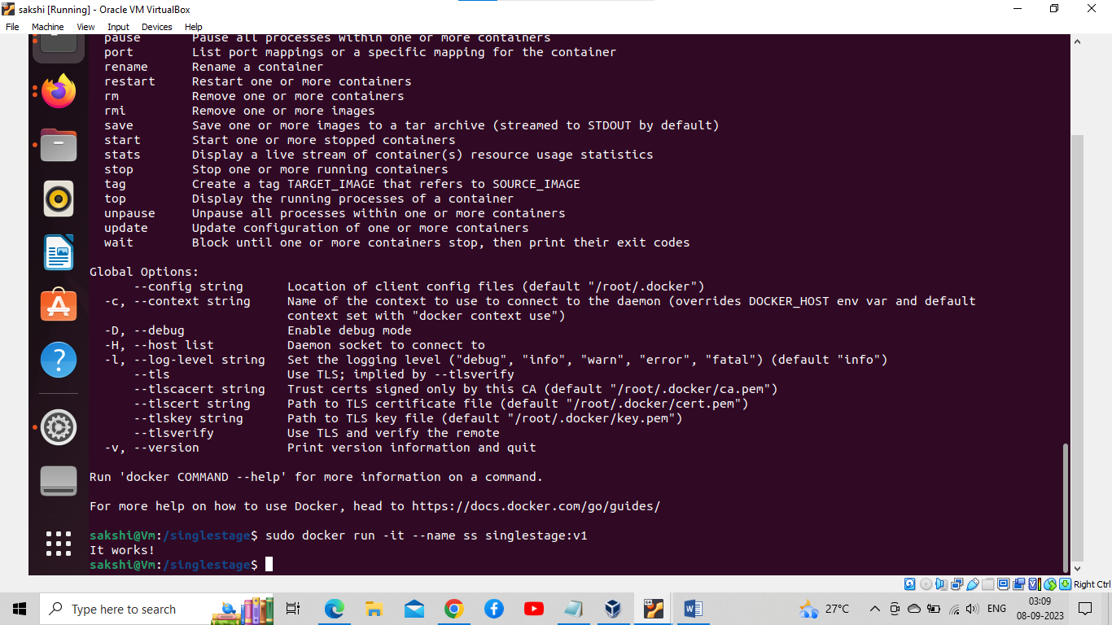

*********multistage try on host _____________________

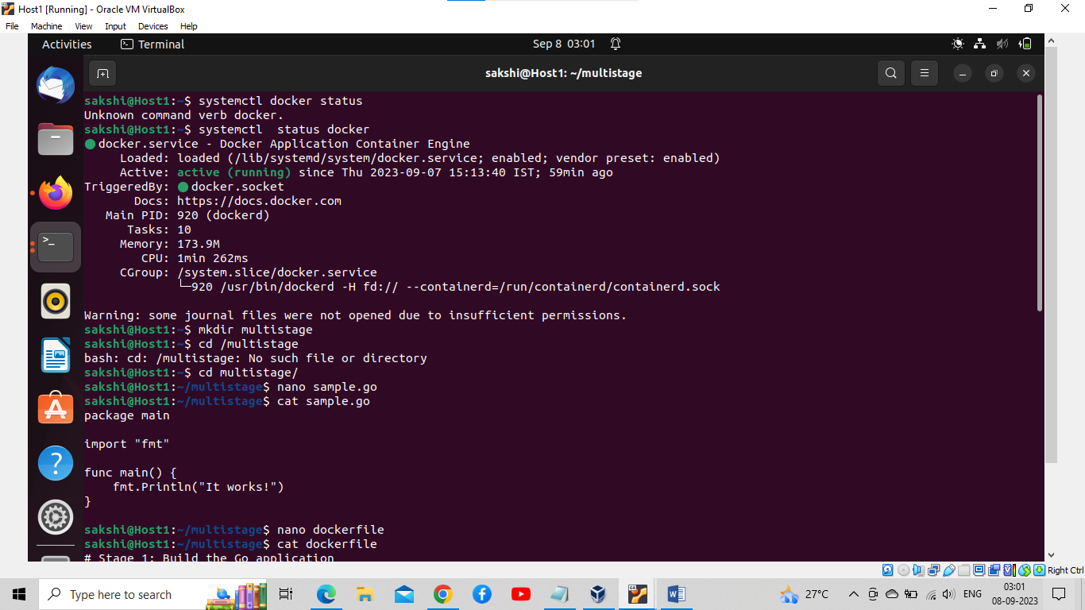

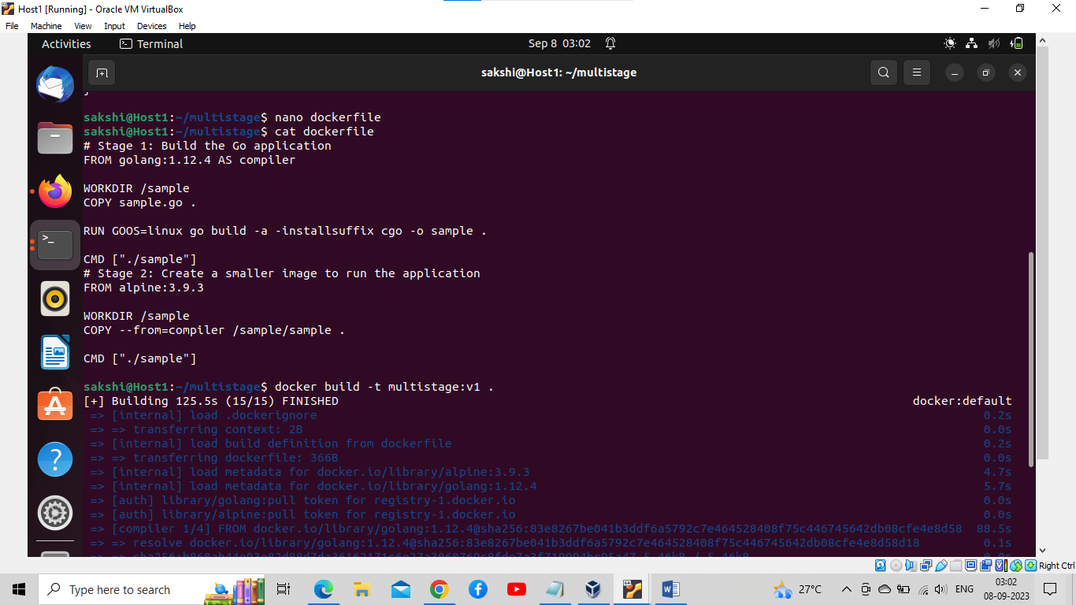

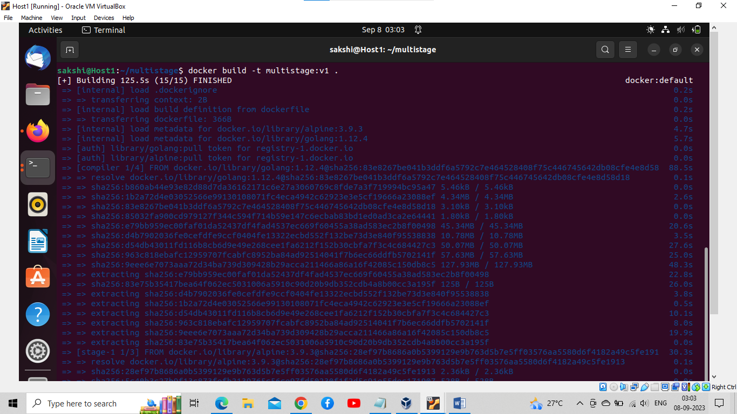

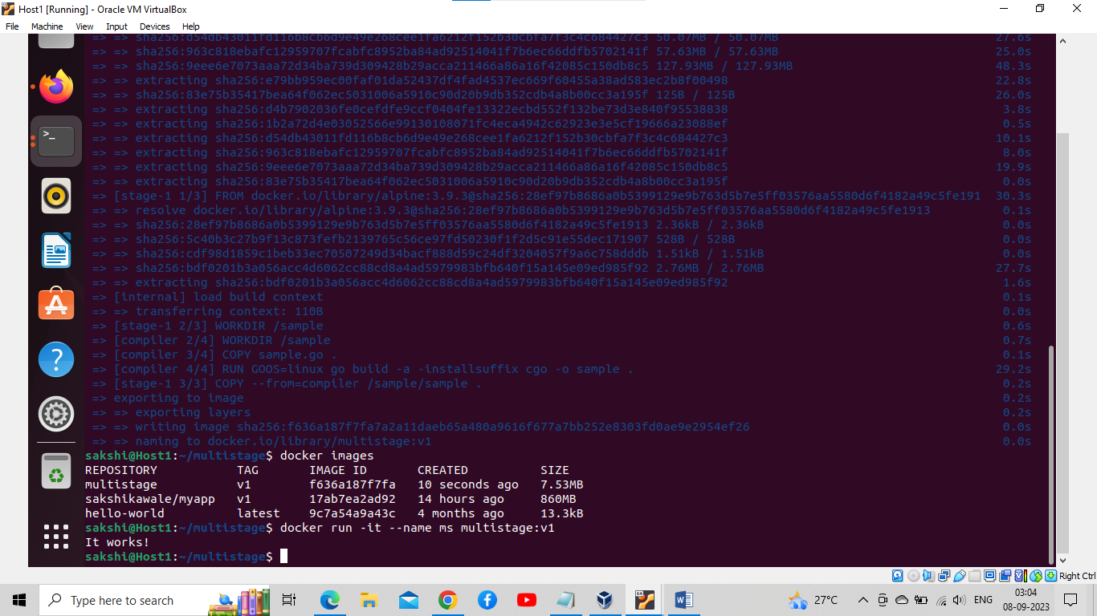

Both stages are perform are well but the dffierence is that multistage images file is much less than singlestage image

Lu2 vid

Docker compose is a tool to run multicontainer application

Docker compose installation

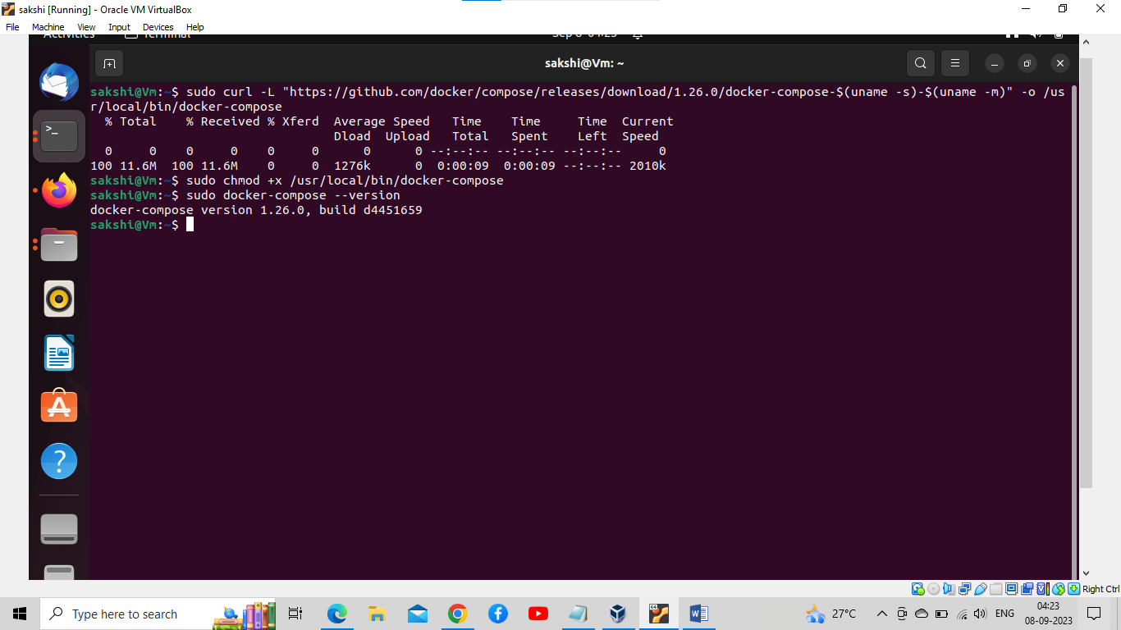

Deploy multicontainer application using compose

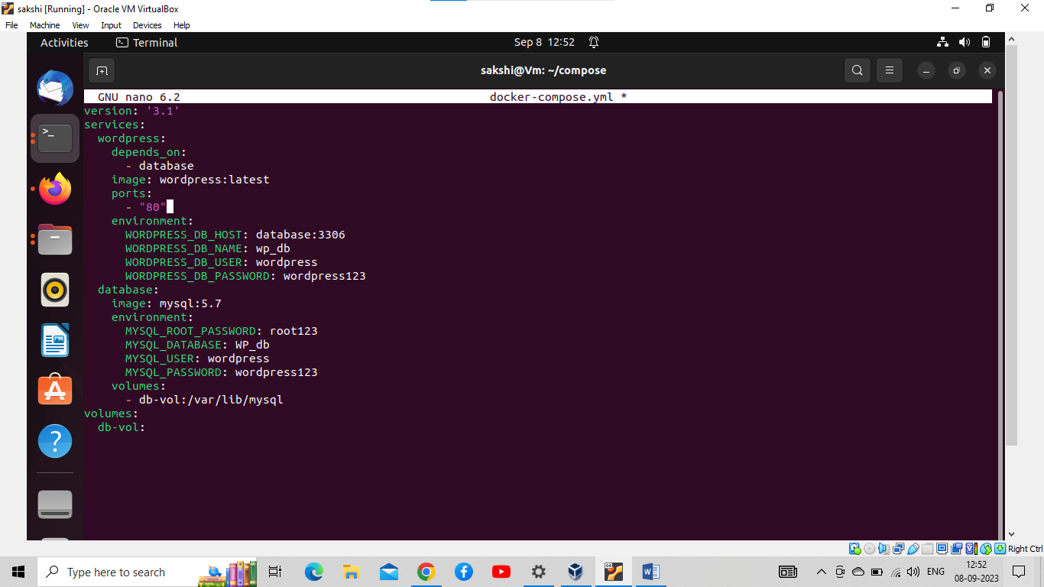

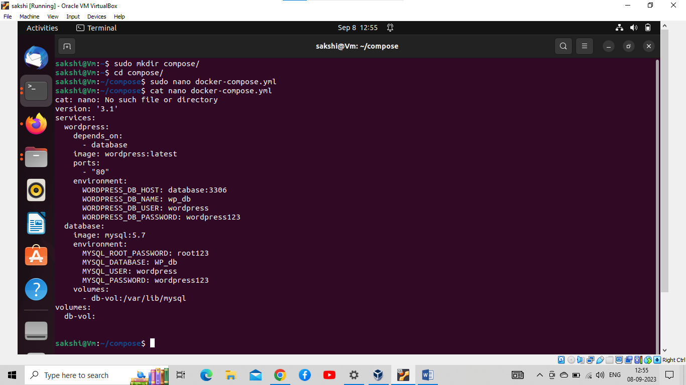

On instance

